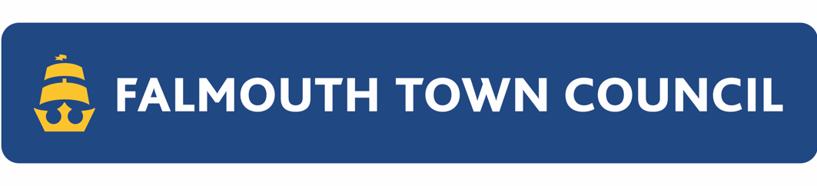GAZEBO HIRE



TERMS AND CONDITIONS

To hire one of Falmouth Town Council’s gazebos for the Weekly Market, you must read and agree to the conditions below. Falmouth Town Council will assess each application on a case-by-case basis and retains the right to reject applications.

Gazebos can be hired from March to December each year. A contractor for Falmouth Town Council will set up and take down the gazebos on trading days. The hire of Falmouth’s Town Council’s gazebos does not include tables, stands or signs; the trader must supply these.

**Terms**

Equipment: the term equipment includes gazebos and gazebo accessories.

Falmouth Town Council hires the following: Gazebos consisting of the frame, roof, weights, and four sides. Gazebo accessories include guttering and joining brackets.

Conditions of Hire:

1. You must be a License Holder for The Moor.
2. The hirer accepts full personal liability for the equipment from the time received until returned at the end of the hire period.
   1. The hirer will take adequate and proper measures to protect the equipment from theft, damage and risks, such as adverse weather. The hirer is responsible for the expense of making good any damage caused during the hire period.
3. The hirer must not attempt to set up, take down or move the gazebo during the hire.

By signing, the hirer acknowledges and accepts the conditions of hire.

**Signature**:

**Name in block capitals:**

**Date**